1. Please give an example to each of the following binary tree types.

* Full binary tree
* Complete binary tree
* Skewed binary tree
* Balanced Binary Tree
* Degenerate (or pathological) tree

1. Design a non-recursive method to traverse a binary tree in postorder.

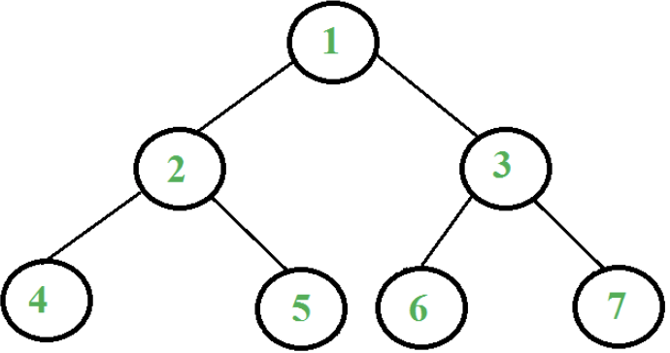

1. Please construct a max-heap tree in both **bottom-up** and **top-down** method from the following array A, and explain how you do it and time complexity.

A[9] = { 2, 5, 1, 8, 9, 3, 6, 4, 7 }

1. Please re-construct all possible binary trees based on each following condition.
2. Inorder traversal sequence : 1 2 3
3. Preorder traversal sequence is equal to postorder traversal sequence
4. Postorder traversal sequence is equal to inorder traversal sequence
5. Answer True or Fales to the following questions and explain your answers.
6. A binary tree re-constructed, based on a given postorder traversal sequence and an inorder traversal sequence, is unique.
7. A binary tree re-constructed, based on a given postorder traversal sequence and a preorder traversal sequence, is unique.
8. Prove that the node of index *k* in complete binary tree is at the height equals ⌊log2k⌋+1 (The height of the root is 1.) *($k≥1$)*
9. Prove that a full binary tree of depth *k* has 2k-1 nodes

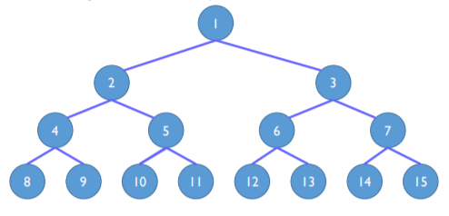

1. Can you apply Max/Min heap for sorting algorithm? If so, explain how to do it.
2. If we use an array to represent a binary tree of n nodes, the indices of nodes can start from 0 to n-1. If the index of a father node is “p”, what are the indices of its left son and right son?
3. Please write a program to calculate the size of a binary tree. The size of a tree is the number of elements present in the tree. For example, the size of the tree below is 5.

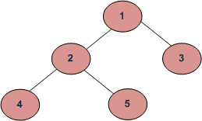

1. Please write a program to count the number of leaf nodes in a binary tree. You must consider two cases: the binary tree is implemented by an array and by a linked list.